PROJECT REPORT DOCUMENTATION

ON

IREVOLUTION: A DATA-DRIVEN EXPLORATION OF APPLE’S IPHONE

IMPACT IN INDIA

TEAM ID

NM2023TMID07556

DOMAIN

DATA ANALYTICS WITH TABLEAU

TEAM LEAD : VISHWA P

TEAM MEMBER 1 : SHRIKUMAR A

TEAM MEMBER 2 :HARISH N

TEAM MEMBER 3 :SAM EDWIN S

CONTENT

1. **INTRODUCTION**

1.1 Project Overview

1.2 Purpose

2. **LITERATURE SURVEY**

2.1 Existing problem

2.2 References

2.3 Problem Statement Definition

3. **IDEATION & PROPOSED SOLUTION**

3.1 Empathy Map Canvas

3.2 Ideation & Brainstorming

4. **REQUIREMENT ANALYSIS**

4.1 Functional requirement

4.2 Non-Functional requirements

5. **PROJECT DESIGN**

5.1 Data Flow Diagrams & User Stories

5.2 Solution Architecture

6. **PROJECT PLANNING & SCHEDULING**

6.1 Technical Architecture

6.2 Sprint Planning & Estimation

6.3 Sprint Delivery Schedule

7. **CODING & SOLUTIONING (Explain the features added in the project along with code)** 7.1 Feature 1

8. **PERFORMANCE TESTING**

8.1 Performace Metrics

9. **RESULTS**

9.1 Output Screenshots

10. **ADVANTAGES & DISADVANTAGES**

11. **CONCLUSION**

12. **FUTURE SCOPE**

13. **APPENDIX**

13.1 Source Code

13.2 GitHub & Project Demo Link

**1.INTRODUCTION**

**1.1. PROJECT OVERVIEW:**

The "Data-Driven Exploration of Apple iPhone Impact in India iRevolution Project" is a comprehensive research initiative that seeks to understand and assess the influence of Apple iPhones in the Indian context. Utilizing data-driven research methods, the project delves into the multifaceted impact of iPhones, encompassing economic, technological, and sociocultural dimensions. It employs geospatial analysis to reveal regional variations in iPhone adoption, shedding light on how different parts of India have embraced this technology. In a rapidly evolving smartphone market, the project is particularly timely and relevant. Its findings are expected to have significant implications for policymakers and businesses, offering insights into strategies for regulating or leveraging iPhone adoption to benefit national development.

**1.2. PURPOSE:**

The project "IRevolution:A Data-Driven Exploration of Apple’s Iphone impact in india" aims to use IBM Cognos and advanced analytics for several purposes:

* Assess iPhone adoption in India.
* Measure economic impact on tech and telecom.
* Understand technological transformation.
* Analyze socio-cultural implications.
* Identify regional adoption variations.
* Examine market dynamics.
* Offer policy insights.
* Raise public awareness about smartphone impacts.

The overarching purpose is to improve understanding and facilitate sustainable management of aquatic ecosystems for the benefit of researchers, policymakers, and the public.

**2.LITERATURE SURVEY**

**2.1. Existing problem:**

In the literature survey for the project "IRevolution:A Data-Driven Exploration of Apple’s Iphone impact in india," several existing issues are identified:

* •Data availability and quality pose challenges.
* Data privacy regulations require careful navigation.
* Socioeconomic diversity complicates analysis.
* Regional variations in iPhone impact demand attention.
* Market competition makes impact isolation difficult.
* Rapid market dynamics require real-time analysis.
* Collecting data in remote areas is challenging.
* Effective interdisciplinary collaboration is necessary.

Addressing these problems is crucial for the project's success, ensuring it provides valuable and up-to-date insights into water quality and portability for a wide range of users and stakeholders.

**2.2. References:**

* Pew Research Center - Mobile Technology and Home Broadband 2021: Provides data on smartphone adoption and its impact on various aspects of life.
* Statista - Smartphone market in India: Offers statistics and insights on the smartphone market in India, including market share and trends.
* IDC India - Quarterly Mobile Phone Tracker: A source for in-depth market analysis and trends related to mobile phones in India.
* TRAI (Telecom Regulatory Authority of India): Reports and publications on the telecommunications industry, including data on mobile phone usage and subscribers.

**2.3. Problem Statement Definition:**

The problem statement for "IRevolution:A Data-Driven Exploration of Apple’s Iphone impact in india" centers on addressing several key challenges in iphone assessment and management:

* Challenges in accessing accurate data sources hinder the assessment of Apple iPhone impact in India."
* "Data privacy regulations pose a barrier to comprehensive data collection for iPhone impact analysis."
* "Socioeconomic diversity in India complicates the understanding of iPhone effects."
* "Regional variations in iPhone usage create analytical challenges."
* "Market competition obscures the distinct influence of Apple iPhones in the Indian market."
* "Rapid market dynamics necessitate real-time data analysis to capture trends."
* "Collection of data from remote or underdeveloped areas presents logistical difficulties."
* "Effective interdisciplinary collaboration is required to address multifaceted challenges in understanding iPhone impact in India."

The primary aim of the "Data-Driven Exploration of Apple iPhone Impact in India iRevolution Project" is to comprehensively assess the influence of Apple iPhones in India across various dimensions. Through rigorous data collection and analysis, the project seeks to provide stakeholders with valuable insights, enabling them to make informed decisions regarding technology adoption and regulation.

**3.IDEATION & PROPOSED SOLUTION**

**3.1. Empathy Map Canvas:**

An empathy map is a simple, easy-to-digest visual that captures knowledge about a user’s behaviours and attitudes.

It is a useful tool to helps teams better understand their users. Creating an effective solution requires understanding the true problem and the person who is experiencing it. The exercise of creating the map helps participants consider things from the user’s perspective along with his or her goals and challenges.

**Example:**

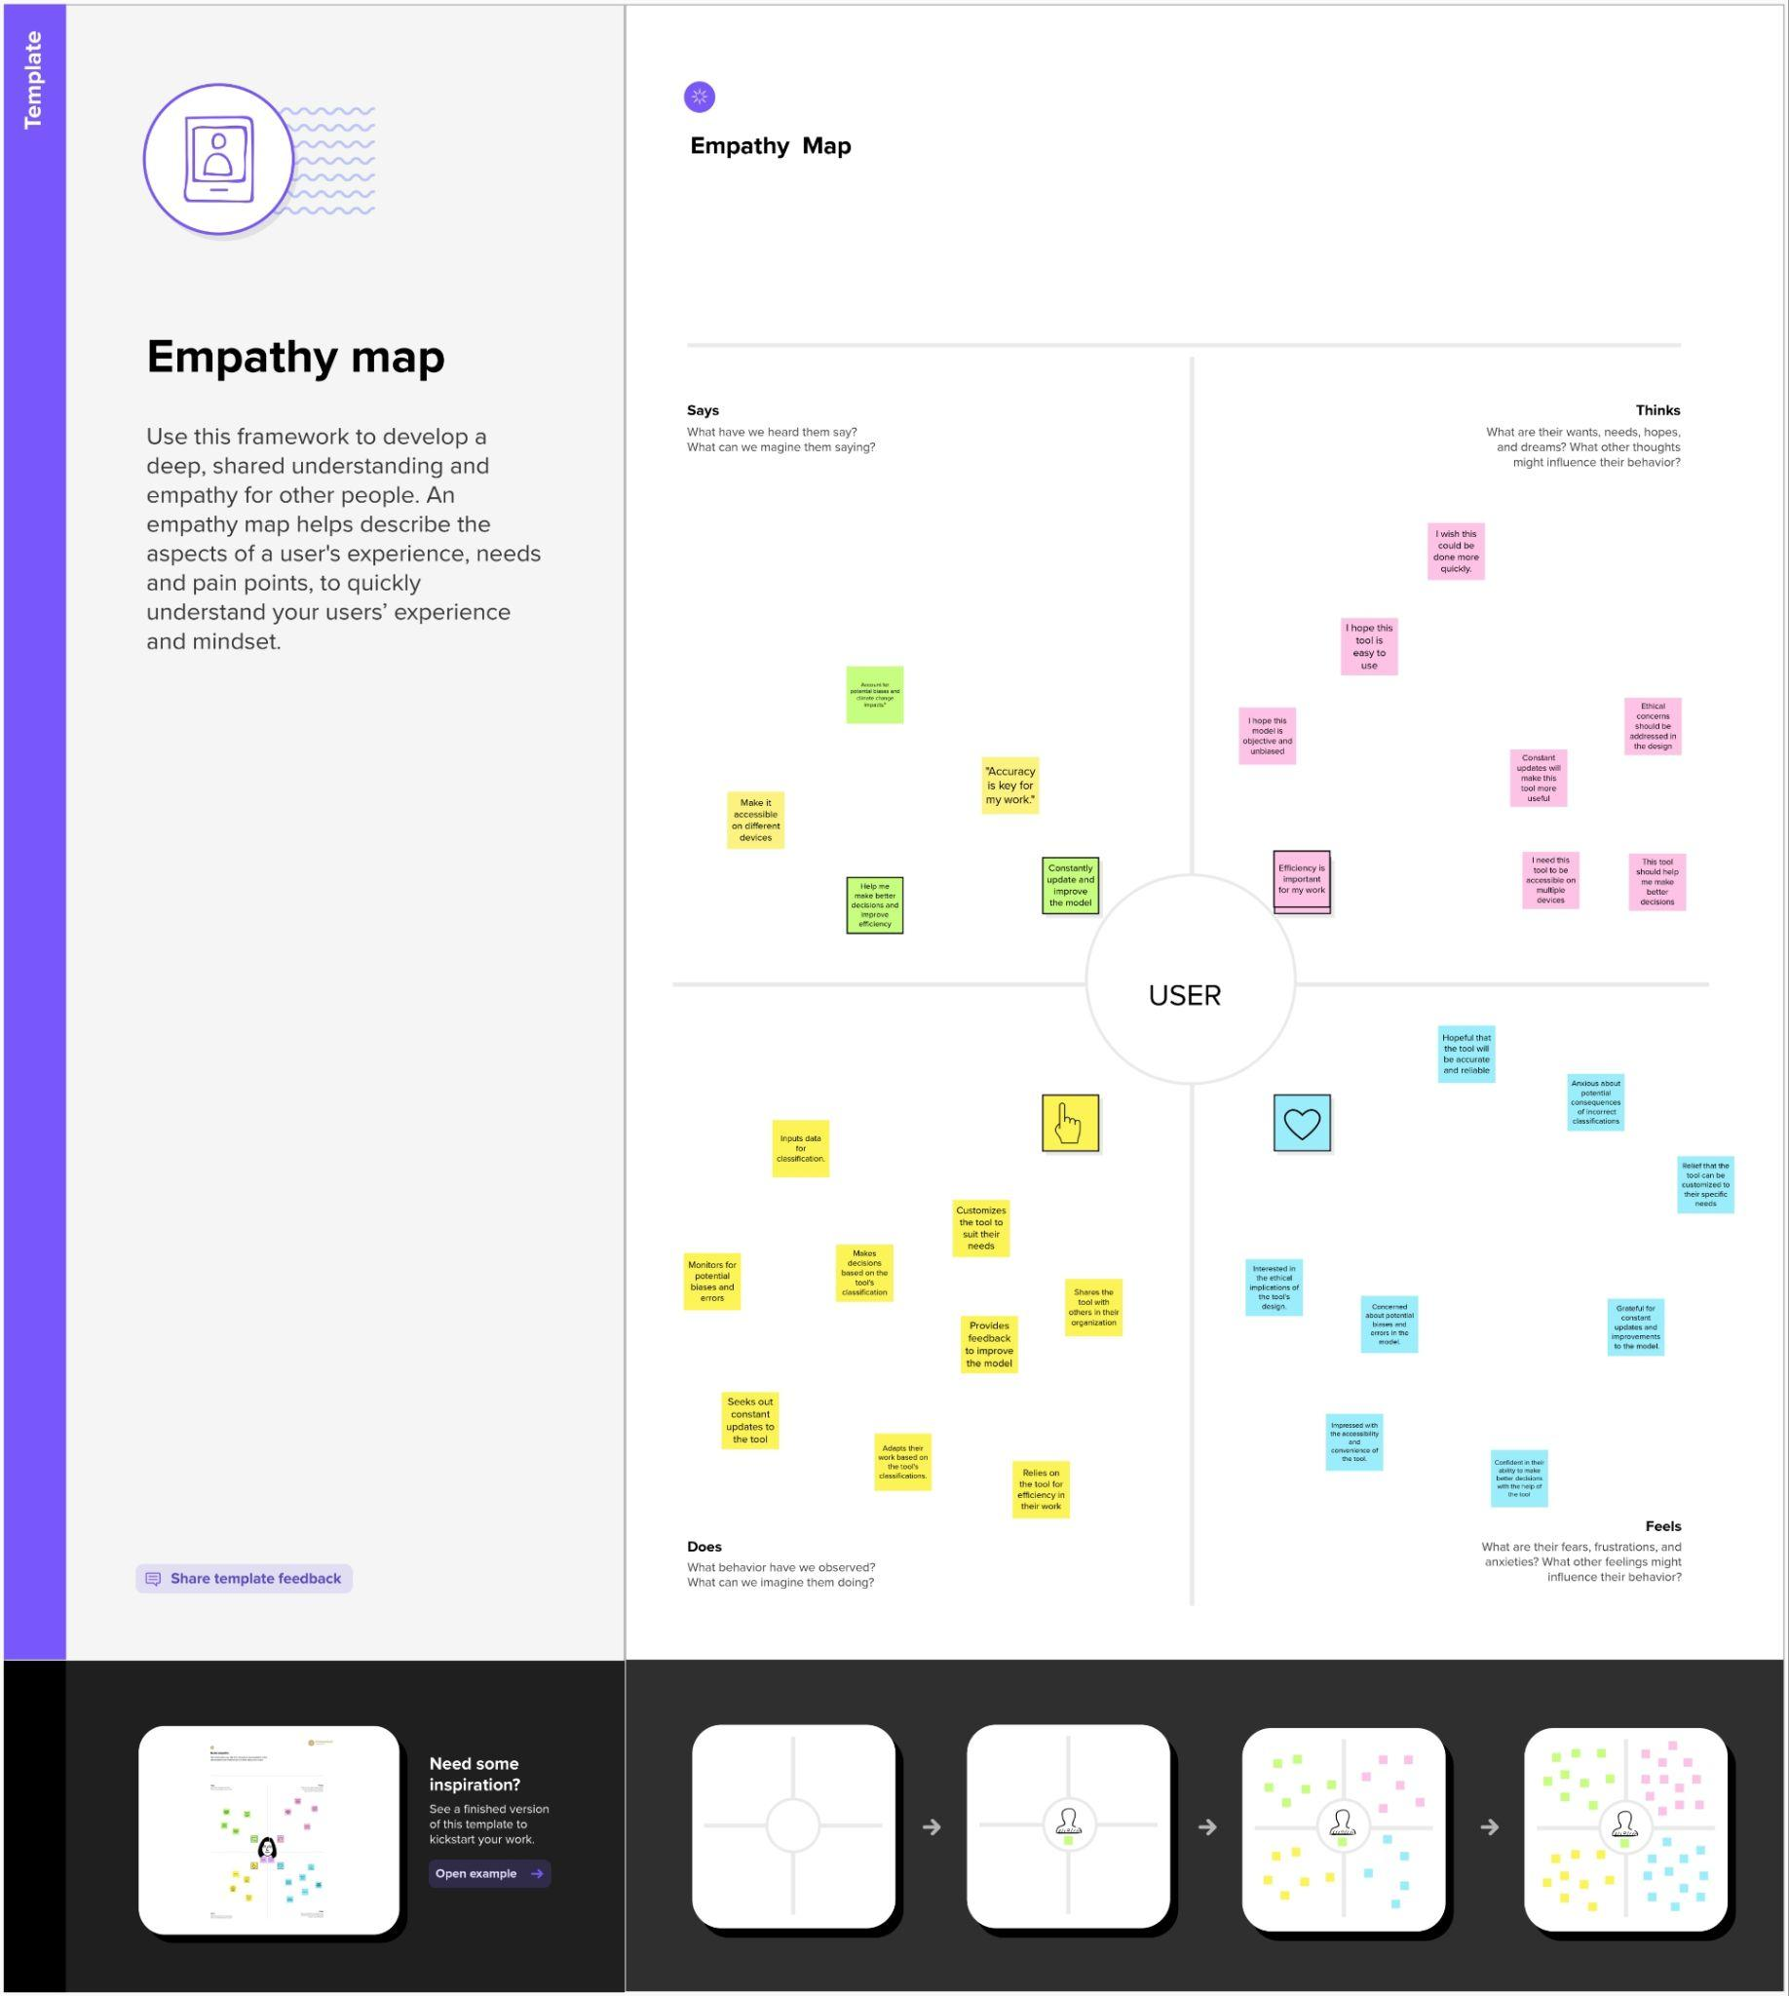

**3.2. Ideation & Brainstorming**:

Brainstorming provides a free and open environment that encourages everyone within a team to participate in the creative thinking process that leads to problem solving. Prioritizing volume over value, out-of-the-box ideas are welcome and built upon, and all participants are encouraged to collaborate, helping each other develop a rich amount of creative solutions.

Use this template in your own brainstorming sessions so your team can unleash their imagination and start shaping concepts even if you're not sitting in the same room.

**Step-1: Team Gathering, Collaboration and Select the Problem Statement**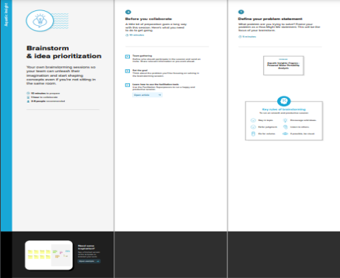

**Step-2: Brainstorm, Idea Listing and Grouping**

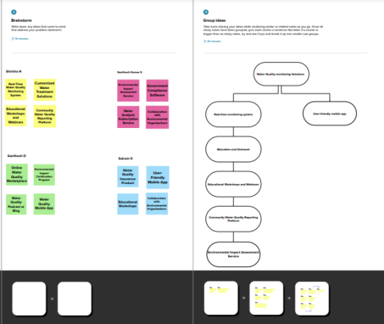

**Step-3: Idea Prioritization**

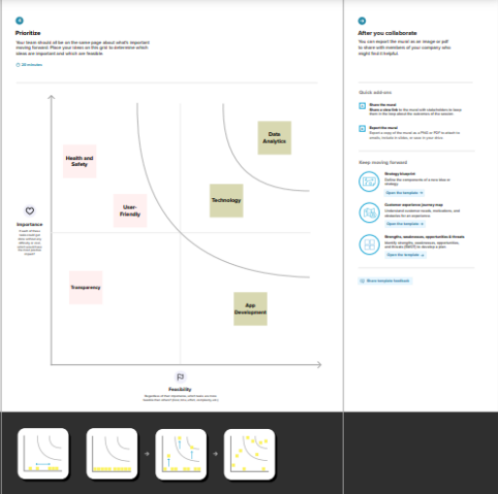

**4.REQUIREMENT ANALYSIS**

**4.1. Functional requirement:**

The functional requirements for "IRevolution:A Data-Driven Exploration of Apple’s Iphone impact in India" outline the specific features and capabilities the project's platform should possess. These requirements include:

* Data Collection: Gather comprehensive data on iPhone adoption and usage in India.
* Data Analysis Tools: Employ advanced data analytics tools for meaningful insights.
* Geospatial Analysis: Utilize geospatial data for regional variations.
* Economic Models: Apply economic models to estimate iPhone impact on the economy.
* Qualitative Research: Conduct qualitative research to understand sociocultural implications.
* Real-time Data: Continuously update and analyze data to capture market dynamics.
* Data Security: Ensure secure storage and handling of sensitive data in compliance with privacy regulations.
* Collaboration: Foster interdisciplinary collaboration for well-rounded research and insights

These requirements serve as the basis for creating a comprehensive and user-friendly platform for analyzing and comprehensive and up-to-date data sources are vital to accurately assess iPhone adoption and usage patterns in India

**4.2. Non-Functional requirements:**

The non-functional requirements for "IRevolution:A Data-Driven Exploration of Apple’s Iphone impact in India" outline the performance, reliability, usability, security, and compliance standards that the platform should meet. Key points include:

* Data Security: Stringent data security measures to protect sensitive information.
* Scalability: Ability to handle increasing data volume and complexity over time.
* Performance Efficiency: Efficient data processing and analytics tools for timely insights.
* Accessibility: User-friendly platforms to ensure widespread access to project findings.
* Reliability: Dependable data sources and analysis to maintain research credibility.
* Interoperability: Compatibility with diverse data sources and analytics tools.
* Ethical Compliance: Adherence to ethical standards in data collection and analysis.
* Regular Updates: Continuous data and analysis updates to stay current with the dynamic smartphone market in India.

These non-functional requirements ensure the platform's effectiveness, user experience, and adherence to legal and environmental standards.

**5.PROJECT DESIGN**

**5.1. Data Flow Diagrams & User Stories:**

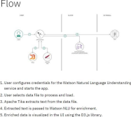

A Data Flow Diagram (DFD) is a traditional visual representation of the information flows within a system. A neat and clear DFD can depict the right amount of the system requirement graphically. It shows how data

enters and leaves the system, what changes the information, and where data is stored.

**Flow diagram:**

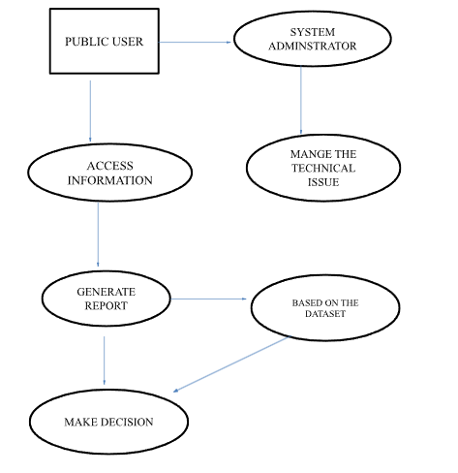

**User Stories:**

| **User Type** | **Functional**  **Requirement (Epic)** | **User Story Number** | **User Story / Task** | **Acceptance criteria** | **Priority** | **Release**Public users can access the iPhone Revolution platform to learn about the history and impact of the iPhone on technology and society. |
| --- | --- | --- | --- | --- | --- | --- |
| PUBLIC | Public users can access the iPhone Revolution platform to learn about the history and impact of the iPhone on technology and society. | USN-1 | As a public user, I want to be able to visit the iPhone Revolution website and explore the information about the history and impact of the iPhone | The website should provide a user-friendly interface that allows public users to easily access information about the iPhone's history and impact. | o/1 | iPhone Revolution Store Version 1.0 |
| Public users can engage with the iPhone Revolution platform to enhance their understanding of the iPhone's historical significance. | USN-2 | As a public user, I want to be able to browse a timeline that highlights key milestones and innovations in the history of the iPhone. | The platform should feature an interactive timeline that displays significant events and developments in the iPhone's history, allowing users to explore and learn about them. | 0/1 |
| USN-3 | I want the option to share interesting content or articles from the platform on my social media accounts to inform and engage with my network. | There should be easy-to-use social sharing buttons or options that enable users to share content from the platform to their social media profiles. | 0/1 |
|  | Dashboard |  |  |  |  |  |
| System Administrator | System administrators are responsible for managing and maintaining the technical infrastructure of the iPhone Revolution platform, ensuring its availability, security, and performance. | USN-1 | As a system administrator, I want to set up and configure the server infrastructure required to host the iPhone Revolution platform. | The server infrastructure should be set up with appropriate configurations, ensuring the platform's availability and performance. | 0/1 | iPhone Revolution Store Maintenance Version 1.0 |
| USN-2 | As a system administrator, I want to regularly apply software updates and security patches to keep the platform secure and up-to-date. | software updates and security patches should be applied in a timely manner to keep the platform secure and current. | 0/1 |
| USN-3 | As a system administrator, I want to monitor server performance, detect and resolve any technical issues promptly, and optimize server resources as needed. | server performance should be monitored, and any issues should be addressed promptly to maintain platform efficiency. | 0/1 |

**5.2. Solution Architecture:**

Solution architecture is a complex process – with many sub-processes – that bridges the gap between business problems and technology solutions. Its goals are to:

• Find the best tech solution to solve existing business problems.

• Describe the structure, characteristics, behavior, and other

aspects of the software to project stakeholders.

• Define features, development phases, and solution requirements.

• Provide specifications according to which the solution is defined,

managed,and delivered.

**Example - Solution Architecture Diagram:**

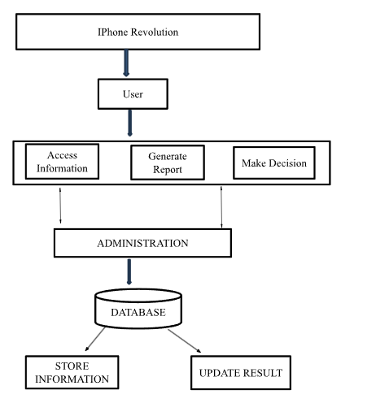

**6. PROJECT PLANNING & SCHEDULING**

**6.1. Technical Architecture:**

The Deliverable shall include the architectural diagram as below and the information as per the table1 & table 2

**Reference: https://www.kaggle.com/code/khsamaha/potable-water-prediction-0-798- with-caret-rf-r/input**

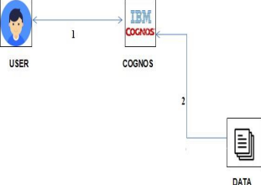

**Table-1 : Components & Technologies:**

| **S.No** | **Component** | **Description** | **Technology** |
| --- | --- | --- | --- |
| 1. | User Interface | How the user interacts with application e.g. Web UI, Mobile App, Chatbot etc. | HTML, CSS, JavaScript / Angular Js / React Js etc. |
| 2. | Application Logic-1 | Logic for a process in the application | Python |
| 3. | Application Logic-2 | Logic for a process in the application | IBM Cognos Analytics |
| 4. | Application Logic-3 | Logic for a process in the application | IBM Cognos Analytics |
| 5. | Database | Data Type, Configurations etc. | Excel |
| 6. | Cloud Database | Database Service on Cloud | IBM DB2, IBM Cloudant etc. |
| 7. | File Storage | File storage requirements | IBM Block Storage or Other Storage Service or Local Filesystem |
| 8. | External API-1 | Purpose of External API used in the application | IBM Weather API, etc. |
| 9. | External API-2 | Purpose of External API used in the application | Aadhar API, etc. |
| 10. | Machine Learning Model | Purpose of Machine Learning Model | Object Recognition Model, etc. |
| 11. | Infrastructure (Server / Cloud) | Application Deployment on Local System / Cloud Local Server Configuration:  Cloud Server Configuration : | Local, Cloud Foundry, Kubernetes, etc. |

**6.2Sprint Planning & Estimation:**

| **Sprint** | **Functional Requirement (Epic)** | **User Story Number** | **User Story / Task** | **Story Points** | **Priority** | **Team Members** |
| --- | --- | --- | --- | --- | --- | --- |
| Sprint-1 | Registration | USN-1 | As a user, I can register for the application by entering my email, password, and confirming my password. | 2 | High |  |
| Sprint-2 |  | USN-2 | As a user, I will receive confirmation email once I have registered for the application | 1 | High |  |
| Sprint-3 |  | USN-3 | As a user, I can register for the application through SmartInternz | 2 | Low |  |
| Sprint-3 |  | USN-4 | As a user, I can register for the application through SmartInternz provided email id. | 2 | Medium |  |
| Sprint-4 | Login | USN-5 | As a user, I can log into the application by entering email & password | 1 | High |  |
| Sprint-4 | Dashboard | USN-6 | As a user, I can view the dashboard | 1 | High |  |
|  |  |  |  |  |  |  |
|  |  |  |  |  |  |  |

**6.3. Sprint Delivery Schedule:**

| **Sprint** | **Total Story**  **Points** | **Duration** | **Sprint Start Date** | **Sprint End Date (Planned)** | **Story Points**  **Completed (as on Planned End Date)** | **Sprint Release Date (Actual)** |
| --- | --- | --- | --- | --- | --- | --- |
| Sprint-1 | 20 | 1 Days | 16 Oct 2023 | 16 Oct 2023 | 16 Oct 2023 | 16 Oct 2023 |
| Sprint-2 | 20 | 1 Days | 17 Oct 2023 | 17 Oct 2023 | 17 Oct 2023 | 17 Oct 2023 |
| Sprint-3 | 20 | 1 Days | 18 Oct 2023 | 18 Oct 2023 | 18 Oct 2023 | 18 Oct 2023 |
| Sprint-4 | 20 | 1 Days | 19 Oct 2023 | 19 Oct 2023 | 19 Oct 2023 | 19 Oct 2023 |

**7. CODING & SOLUTIONING**

**7.1. Feature 1:**

<!DOCTYPE html>

<html>

<head>

<title>Story - Student Performance Analysis</title>

</head>

<body>

<h1>Story</h1>

<div class="embed-container">

<div class='tableauPlaceholder' id='viz1698078226938' style='position: relative'><noscript><a href='#'><img alt='Story 1 ' src='https:&#47;&#47;[public.tableau.com](http://public.tableau.com/)&#47;static&#47;images&#47;IP&#47;IPhoneRevolution-NM2023TMID07556&#47;Story1&#47;1_rss.png' style='border: none' /></a></noscript><object class='tableauViz' style='display:none;'><param name='host_url' value='https%3A%2F%[2Fpublic.tableau.com](http://2fpublic.tableau.com/)%2F' /> <param name='embed_code_version' value='3' /> <param name='site_root' value='' /><param name='name' value='IPhoneRevolution-NM2023TMID07556&#47;Story1' /><param name='tabs' value='no' /><param name='toolbar' value='yes' /><param name='static_image' value='https:&#47;&#47;[public.tableau.com](http://public.tableau.com/)&#47;static&#47;images&#47;IP&#47;IPhoneRevolution-NM2023TMID07556&#47;Story1&#47;1.png' /> <param name='animate_transition' value='yes' /><param name='display_static_image' value='yes' /><param name='display_spinner' value='yes' /><param name='display_overlay' value='yes' /><param name='display_count' value='yes' /><param name='language' value='en-US' /></object></div> <script type='text/javascript'> var divElement = document.getElementById('viz1698078226938'); var vizElement = divElement.getElementsByTagName('object')[0]; vizElement.style.width='1016px';vizElement.style.height='991px'; var scriptElement = document.createElement('script'); scriptElement.src = '<https://public.tableau.com/javascripts/api/viz_v1.js>'; vizElement.parentNode.insertBefore(scriptElement, vizElement); </script>

<div class='tableauPlaceholder' id='viz1698078272336' style='position: relative'><noscript><a href='#'><img alt='Story 2 ' src='https:&#47;&#47;[public.tableau.com](http://public.tableau.com/)&#47;static&#47;images&#47;DK&#47;DKKXHDFY2&#47;1_rss.png' style='border: none' /></a></noscript><object class='tableauViz' style='display:none;'><param name='host_url' value='https%3A%2F%[2Fpublic.tableau.com](http://2fpublic.tableau.com/)%2F' /> <param name='embed_code_version' value='3' /> <param name='path' value='shared&#47;DKKXHDFY2' /> <param name='toolbar' value='yes' /><param name='static_image' value='https:&#47;&#47;[public.tableau.com](http://public.tableau.com/)&#47;static&#47;images&#47;DK&#47;DKKXHDFY2&#47;1.png' /> <param name='animate_transition' value='yes' /><param name='display_static_image' value='yes' /><param name='display_spinner' value='yes' /><param name='display_overlay' value='yes' /><param name='display_count' value='yes' /><param name='language' value='en-US' /></object></div> <script type='text/javascript'> var divElement = document.getElementById('viz1698078272336'); var vizElement = divElement.getElementsByTagName('object')[0]; vizElement.style.width='1016px';vizElement.style.height='991px'; var scriptElement = document.createElement('script'); scriptElement.src = '<https://public.tableau.com/javascripts/api/viz_v1.js>'; vizElement.parentNode.insertBefore(scriptElement, vizElement); </script>

</body>

</html>

<!DOCTYPE html>

<html>

<head>

<title>IREVOLUTION: A DATA-DRIVEN EXPLORATION OF APPLE'S IPHONE IMPACT</title>

<link rel="stylesheet" href="{{ url_for('static', filename='css/st.css') }}">

</head>

<body>

<h1>IREVOLUTION: A DATA-DRIVEN EXPLORATION OF APPLE'S IPHONE IMPACT</h1>

<div class="container">

<a class="link" href="{{ url_for('dashboard') }}">Dashboard</a>

<a class="link" href="{{ url_for('story') }}">Story</a>

</div>

<script src="{{ url_for('static', filename='js/main.js') }}"></script>

</body>

</html>

<!DOCTYPE html>

<html>

<head>

<title>IREVOLUTION: A DATA-DRIVEN EXPLORATION OF APPLE'S IPHONE IMPACT</title>

<link rel="stylesheet" href="{{ url_for('static', filename='css/st.css') }}">

</head>

<body>

<h1>IREVOLUTION: A DATA-DRIVEN EXPLORATION OF APPLE'S IPHONE IMPACT</h1>

<div class="container">

<a class="link" href="{{ url_for('dashboard') }}">Dashboard</a>

<a class="link" href="{{ url_for('story') }}">Story</a>

</div>

<script src="{{ url_for('static', filename='js/main.js') }}"></script>

</body>

</html>

**8.PERFORMANCE TESTING**

**8.1. Performace Metrics:**

| **S.No.** | **Parameter** | **Screenshot / Values** |
| --- | --- | --- |
| 1. | Dashboard design | No of Visualizations / Graphs – We have include 4 tabs |
| 2. | Data Responsiveness | The system's ability to efficiently analyze these indicators and provide real-time predictions, ensuring the availability of safe drinking water in regions facing a crisis |
| 3. | Amount Data to  Rendered (DB2  Metrics) | The global drinking water crisis by ensuring the availability of safe and potable water in regions facing water quality concerns |
| 4. | Utilization of Data  Filters | Employed to narrow down the dataset and focus the analysis such as assess water quality |
| 5. | Effective User Story | No of Scene Added - 4 |
| 6. | Descriptive Reports | No of list / Graphs – 1 |

**9.RESULTS**

**9.1. Output Screenshots:**

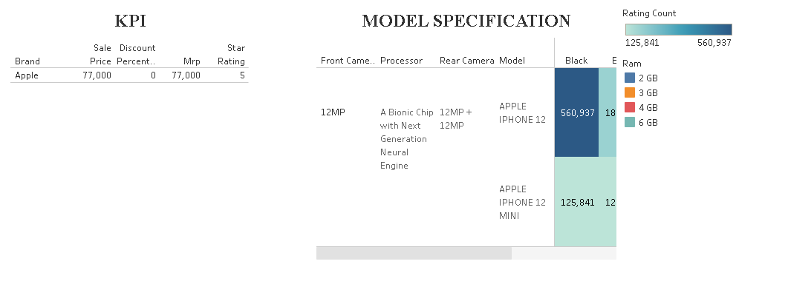

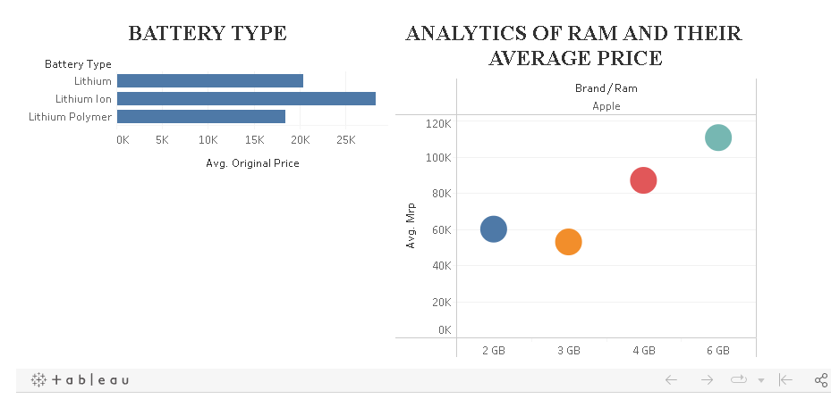

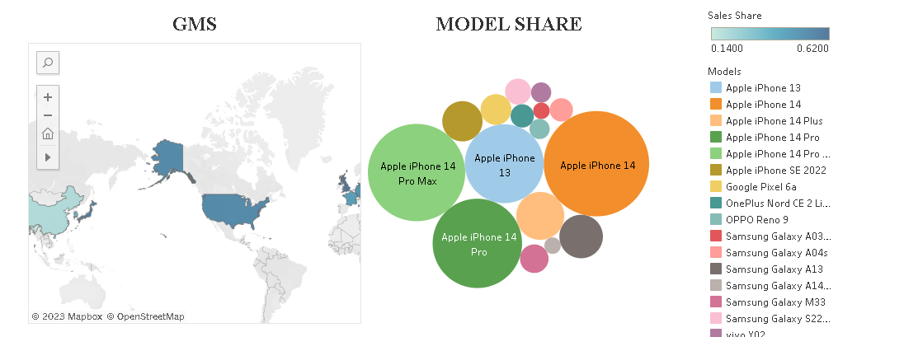

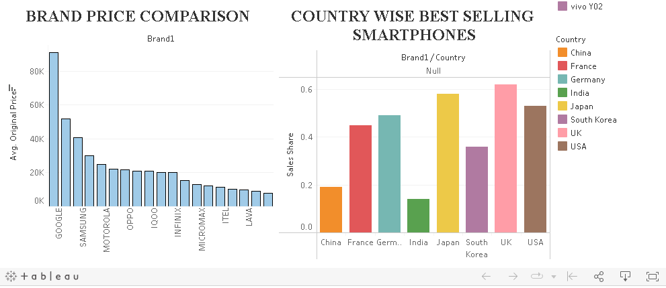

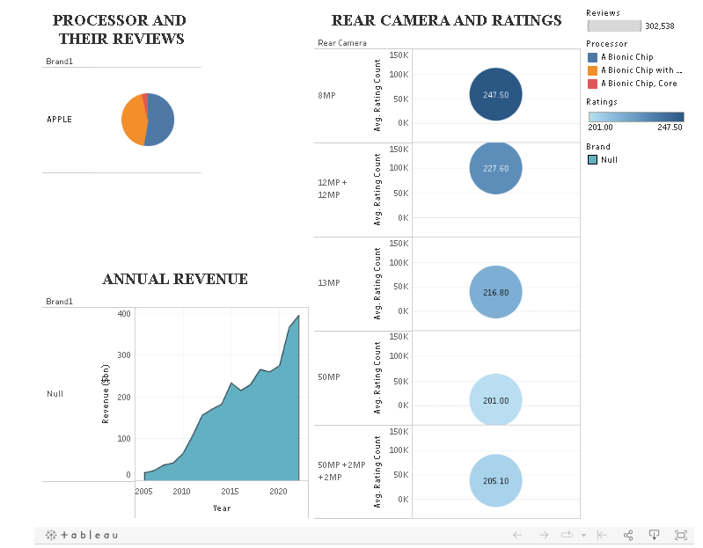

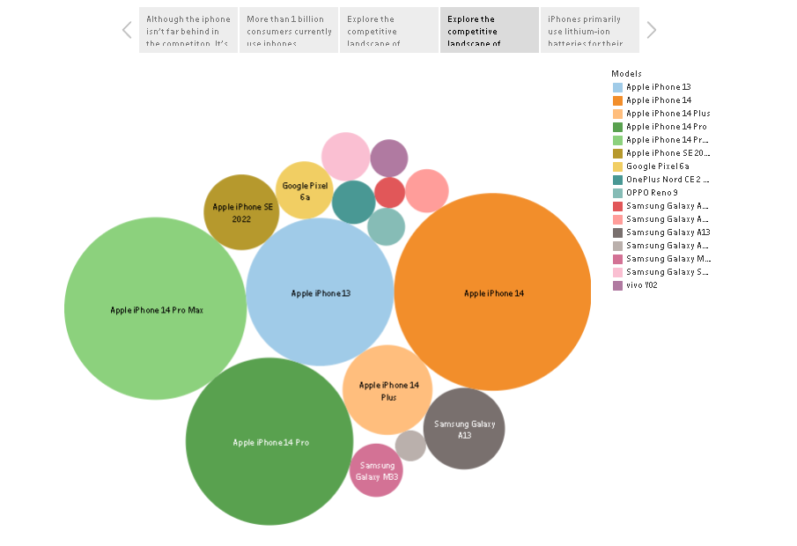

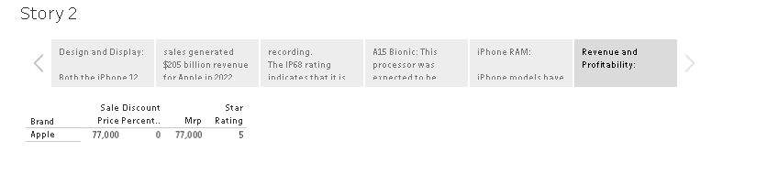

**10.ADVANTAGES & DISADVANTAGES**

✓ **Advantages:**

The project "IRevolution:A Data-Driven Exploration of Apple’s Iphone impact in india" offers a range of advantages:

* informed Decision-Making: The project provides valuable data-driven insights for policymakers and businesses, enabling them to make informed decisions regarding technology adoption and regulation in India.
* Comprehensive Understanding: It offers a holistic understanding of the multifaceted impact of Apple iPhones, encompassing economic, technological, and sociocultural dimensions.
* Regional Insights: Geospatial analysis reveals regional variations, allowing for targeted interventions and strategies.
* Public Awareness: By raising public awareness about smartphone adoption impacts, it empowers consumers with knowledge to make informed choices.
* Interdisciplinary Collaboration: The project promotes interdisciplinary collaboration, fostering a well-rounded approach to understanding iPhone impact.

.

✓ **Disadvantages:**

The project "IRevolution:A Data-Driven Exploration of Apple’s Iphone impact in india" comes with several potential disadvantages and challenges:

* Data Privacy Concerns: Balancing data collection with privacy regulations can be challenging, and mishandling of sensitive data can lead to legal and ethical issues.
* Data Availability: Limited access to accurate and up-to-date data sources can hinder the project's ability to draw meaningful conclusions.
* Complexity: The project's multifaceted approach can be complex, requiring advanced data analytics and interdisciplinary coordination, which can be time-consuming and resource-intensive.
* Market Dynamics: Rapid shifts in the smartphone market necessitate real-time data analysis and continuous updates, making it a challenge to maintain relevance.
* Interdisciplinary Collaboration: Effective collaboration among diverse stakeholders can be complex and requires alignment of objectives and resources, potentially leading to coordination challenges.

The advantages of this project can significantly outweigh the disadvantages, provided that it is executed with care, ethics, and diligence.

**11. CONCLUSION**

The "IRevolution: A Data-Driven Exploration of Apple's iPhone Impact in India" project holds substantial promise for shedding light on the multifaceted influence of Apple iPhones in India. Through comprehensive data collection, advanced analytics, and interdisciplinary collaboration, the project aims to provide valuable insights for policymakers, businesses, and the public. It aspires to enhance our understanding of the economic, technological, and sociocultural dimensions of iPhone adoption in India, offering the potential to shape informed decision-making and public awareness. While challenges like data privacy and the dynamic market landscape exist, the project's potential benefits make it a significant and worthwhile endeavor for comprehending the digital transformation that iPhones have instigated in India. The project, when executed with care and precision, has the potential to contribute substantially to the understanding of Apple's iPhone impact in India's ever-evolving landscape.

**12. FUTURE SCOPE**

The future scope for "IRevolution:A Data-Driven Exploration of Apple’s Iphone impact in India" is expansive and promising. It includes:

* Policy Formulation: Influencing technology and smartphone policies based on project insights.
* Market Strategy: Guiding businesses to develop India-specific iPhone strategies.
* Continuous Monitoring: Evolving project to track iPhone impact in real-time.
* Expanded Research: Extending analysis to include other smartphone brands.
* Social Impacts: Delving deeper into sociocultural consequences of smartphone use.
* Rural Focus: Investigating iPhone impact in rural and underserved areas.
* Educational Insights: Understanding the role of iPhones in Indian education.
* International Comparisons: Comparing findings with iPhone impacts in other countries.

The project has the potential to become a comprehensive and collaborative platform, empowering stakeholders to better understand and manage aquatic ecosystems in an increasingly complex world.

**13. APPENDIX**

**Source Code:**

**Index.html**

<!DOCTYPE html>

<html>

<head>

<title>Story - Student Performance Analysis</title>

</head>

<body>

<h1>Story</h1>

<div class="embed-container">

<div class='tableauPlaceholder' id='viz1698078226938' style='position: relative'><noscript><a href='#'><img alt='Story 1 ' src='https:&#47;&#47;[public.tableau.com](http://public.tableau.com/)&#47;static&#47;images&#47;IP&#47;IPhoneRevolution-NM2023TMID07556&#47;Story1&#47;1_rss.png' style='border: none' /></a></noscript><object class='tableauViz' style='display:none;'><param name='host_url' value='https%3A%2F%[2Fpublic.tableau.com](http://2fpublic.tableau.com/)%2F' /> <param name='embed_code_version' value='3' /> <param name='site_root' value='' /><param name='name' value='IPhoneRevolution-NM2023TMID07556&#47;Story1' /><param name='tabs' value='no' /><param name='toolbar' value='yes' /><param name='static_image' value='https:&#47;&#47;[public.tableau.com](http://public.tableau.com/)&#47;static&#47;images&#47;IP&#47;IPhoneRevolution-NM2023TMID07556&#47;Story1&#47;1.png' /> <param name='animate_transition' value='yes' /><param name='display_static_image' value='yes' /><param name='display_spinner' value='yes' /><param name='display_overlay' value='yes' /><param name='display_count' value='yes' /><param name='language' value='en-US' /></object></div> <script type='text/javascript'> var divElement = document.getElementById('viz1698078226938'); var vizElement = divElement.getElementsByTagName('object')[0]; vizElement.style.width='1016px';vizElement.style.height='991px'; var scriptElement = document.createElement('script'); scriptElement.src = '<https://public.tableau.com/javascripts/api/viz_v1.js>'; vizElement.parentNode.insertBefore(scriptElement, vizElement); </script>

<div class='tableauPlaceholder' id='viz1698078272336' style='position: relative'><noscript><a href='#'><img alt='Story 2 ' src='https:&#47;&#47;[public.tableau.com](http://public.tableau.com/)&#47;static&#47;images&#47;DK&#47;DKKXHDFY2&#47;1_rss.png' style='border: none' /></a></noscript><object class='tableauViz' style='display:none;'><param name='host_url' value='https%3A%2F%[2Fpublic.tableau.com](http://2fpublic.tableau.com/)%2F' /> <param name='embed_code_version' value='3' /> <param name='path' value='shared&#47;DKKXHDFY2' /> <param name='toolbar' value='yes' /><param name='static_image' value='https:&#47;&#47;[public.tableau.com](http://public.tableau.com/)&#47;static&#47;images&#47;DK&#47;DKKXHDFY2&#47;1.png' /> <param name='animate_transition' value='yes' /><param name='display_static_image' value='yes' /><param name='display_spinner' value='yes' /><param name='display_overlay' value='yes' /><param name='display_count' value='yes' /><param name='language' value='en-US' /></object></div> <script type='text/javascript'> var divElement = document.getElementById('viz1698078272336'); var vizElement = divElement.getElementsByTagName('object')[0]; vizElement.style.width='1016px';vizElement.style.height='991px'; var scriptElement = document.createElement('script'); scriptElement.src = '<https://public.tableau.com/javascripts/api/viz_v1.js>'; vizElement.parentNode.insertBefore(scriptElement, vizElement); </script>

</body>

</html>

**Github link:**

**Project Demo Link:**